Policz po angielsku i zaznacz poprawną ilość zabawek na obrazkach.

How many balls can you see?

1

4

3
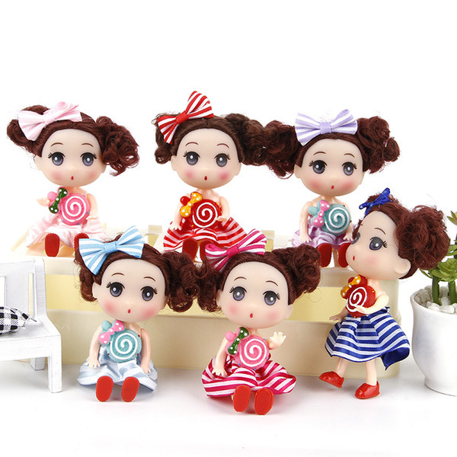 | How many dolls can you see?  8  6  5
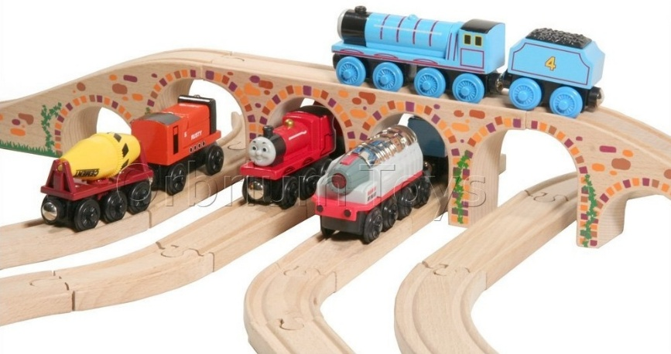 | How many trains can you see?  7  4  2
How many kites can you see?

5

7

4
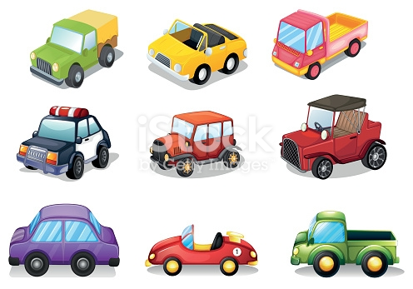 | How many cars can you see?  9  6  10
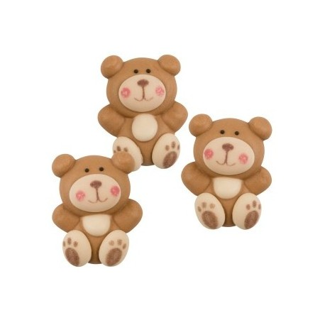 | How many teddies can you see?  2  4  3

