Język angielski
Old MacDonald had a farm
Ee i ee i o
And on his farm he had some cows
Ee i ee i oh
With a moo-moo here
And a moo-moo there
Here a moo, there a moo
Everywhere a moo-moo
Old MacDonald had a farm
Ee i ee i o
Old MacDonald had a farm
Ee i ee i o
And on his farm he had some chicks
Ee i ee i o
With a cluck-cluck here
And a cluck-cluck there
Here a cluck, there a cluck
Everywhere a cluck-cluck
Old MacDonald had a farm
Ee i ee i o
Old MacDonald had a farm
Ee i ee i o
And on his farm he had some pigs
Ee i ee i o
With an oink-oink here
And an oink-oink there
Here an oink, there an oink
Everywhere an oink-oink
Old MacDonald had a farm
Ee i ee i o

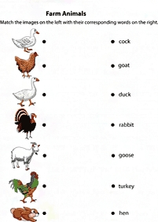
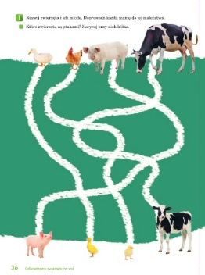
Wytnij i ułóż w odpowiedniej kolejności. Podpisz obrazek.
